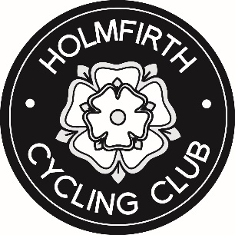
HOLMFIRTH CYCLING CLUB
PARENTAL CONSENT FORM FOR YOUNG RIDERS JOINING CLUB RIDES

Holmfirth Cycling Club are keen to encourage young members who want to join organised club rides.
All club members participating in club activities do so at their own risk.
Young Riders aged 16 and below may do so ONLY with signed parental consent.
The attached form should be completed and returned to the club secretary BEFORE you join your first club ride.

Joining HCC club rides. Young rider pathway.
The following criteria must be met;
Young riders (under 16) joining club rides must:
- Be ‘accredited’ by club coaches as being suitable (skills and fitness) for joining club rides
- Submit a completed parental consent form – retained by HCC club secretary
- Identify and agree with a responsible person who will act as that riders ‘chaperone’ throughout the ride – this must be agreed BEFORE each ride meet.
- Carry an ID and I.C.E. card which they must show the ride leader/planner and chaperone prior to commencing the ride.
Please remember that you will be representing Holmfirth Cycling Club and that you are expected to ride according to the Highway Code and the rules of the road.
Any behaviour which is dangerous, illegal or likely to bring the club into disrepute may result in suspension from attending club rides or expulsion from the club.
Please return the attached consent form to:
HCC Secretary
25 Longlands Bank,
Thongsbridge, Holmfirth.
HD97HR
Or email to: secretary@holmfirthcc.com

